WinCE5.0 eBoot and Kernel Porting Guide

Version 0.1

Shmt Co., Ltd.

REVISION HISTORY PAGE

Issue | Rev No. | Originator | Details of Change | Date
1 | 0.1 | DJKIM | Initial Version | 2006-06-15

Technical documents for WinCE5.0 eBoot and Kernel porting

Copyright © 2006 Shmt Limited. All rights reserved.

Confidentiality Status
This document is NOT OPEN ACCESS. The distribution is restricted to certified company.
This document is CONFIDENTIAL.

Feedback on this document
If you have any comments on this document, please contact your channel to our company.

Shmt Web address
http://www.shmt.com

Contents

1. INTRODUCTION 7
2. OverView 8
3. Boot Loader 11
3.1. Boot Loader Startup Sequence 11
4. Kernel 14
4.1. Kernel Startup Sequence 14
5. HowTo Porting 18
5.1. Boot Loader Development 18
5.2. Kernel Development 19
5.3. Boot Loader Porting List 22
5.4. Kernel Porting List 23
5.5. Configuration File 24
6. Debugging and Testing 25
6.1. Boot Loader 27
6.2. Kernel 27
APPENDIX 30
A. Reference 30
B. Important Functions 30

Figures
[Table - 1] Boot Loader Startup Sequence 11
[Table - 2] Return codes for the OEMPreDownload 13
[Table - 3] Kernel Startup Sequence 15
[Table - 4] Boot Loader Porting Files 23
[Table - 5] Kernel Porting Files 24
[Table - 6] Configure Files 25
[Table - 7] Debugging Resource Overview 26
[Table - 8] Remote Tools in the Platform Builder 29

Tables
[Table - 1] Boot Loader Startup Sequence 11
[Table - 2] Return codes for the OEMPreDownload 13
[Table - 3] Kernel Startup Sequence 15
[Table - 4] Boot Loader Porting Files 23
[Table - 5] Kernel Porting Files 24
[Table - 6] Configure Files 25
[Table - 7] Debugging Resource Overview 26
[Table - 8] Remote Tools in the Platform Builder 29

INTRODUCTION

This document treats the porting of boot loader and kernel in the WinCE5.0.
BSP(Board Support Package) referred to S3C2440(Samsung arm9 process) of the WinCE4.2.

OverView

The following figure is the whole structure of the WinCE.

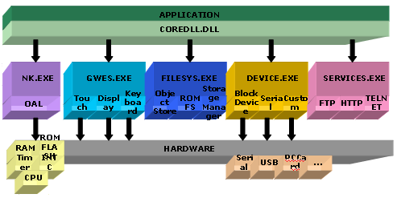
* OAL : OEM Adaptation Layer
* GWES : Graphics Windowing and Events Sub-system
[Fig - ] The Whole structur of the WinCE

Like many development tasks, the process for developing a BSP involves high-level and low-level tasks. For example, at the highest level, you must select the hardware platform, and at the lowest level, you must develop a boot loader and the OEM abstraction layer (OAL) for the kernel. The following illustration shows the high-level steps needed to develop the low-level software for a BSP.

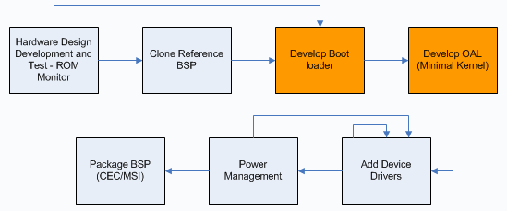
[Fig - ] BSP Develop Process

You begin by selecting or developing the hardware platform that the BSP will target. This includes developing a board with a CPU that can run the Windows CE operating system (OS), selecting the peripheral devices that will interface with the device, and including the interfaces required to support BSP development and debugging. For example, you might not need to include support for serial connections on a device for consumers, but a serial connection is typically important for low-level software development. You should consider populating your device with a debug header that can interface to a debug board for development, but can be depopulated before the device is used for production.
After you have identified and created the hardware platform, you must develop a BSP that will run Windows CE on the device. Often, you can modify a BSP from Microsoft or a third party, which will greatly reduce your BSP development work. The process of starting with a BSP from Microsoft is called BSP cloning. You can find information about this process in the Windows CE Help documentation. If a BSP is not available, you will have to develop one entirely on your own. Because developing a BSP entirely on your own is a significant amount of work, Microsoft recommends that you start with a BSP from Microsoft or a third party.
At this point, you move to the low-level development tasks by developing a boot loader that can reside in persistent memory on the device. The boot loader's primary function is to initialize enough of the hardware and CPU to allow the hardware to communicate with the development environment for downloading a Windows CE-based run-time image. You can extend the boot loaders functionality to be used for any other purpose that your device requires. Later sections of this paper discuss the low-level startup functions that you must implement in the boot loader.
After a boot loader has been developed, you download it and write it into persistent memory on the device using the tools specified by the silicon vendor. You then start development work on the OAL portion of the BSP. Part of the OAL work consists of implementing the bootstrapping kernel functions required to start the Windows CE kernel. Developing the OAL is a step-by-step process of implementing the startup functions and implementing the code that will initialize the hardware on the device in preparation for running the Windows CE kernel. You can leverage or share many of the startup functions that are implemented in the boot loader during OAL development. Once you have developed, downloaded, and debugged the OAL, a minimal Windows CE kernel will be running on the hardware platform.
Next, you add support for the peripherals that you have chosen for the device. To do this, you have to iteratively add and debug the drivers for these peripherals one at a time. If you have multiple developers working on drivers, the drivers can be developed in a series and added to the BSP one at a time. Depending on what peripherals you have chosen, or if you are using a System-On-Chip (SOC), you can add drivers from Microsoft or from a third party. You can leverage these drivers as the starting point for each driver that you develop.
Once the device drivers have been developed, you should have a BSP with an OAL and the drivers for each peripheral that you intend to support on the hardware platform. Next, you will plan and implement power management.
Power management is an important part of the driver and BSP development process. Once you have planned your power management system, which includes deciding to what extent your device will rely on battery power, you will use the Power Manager to help you implement those power management capabilities. Although power management is not the focus of this article, you can find documentation that explicitly covers power management in Windows CE Help and the MSDN Library. There you will find details about how to make each peripheral driver power-management-aware, as well as how drivers interact with the Power Manager and OAL.
As you develop the OAL, bring up device drivers, and implement power management, you must test each component. The Windows CE Test Kit (CETK) provides a wide variety of tests to help you with this process. For information about the CETK, see Windows CE Help and the MSDN Library.
The final steps in the BSP development process are to create a software development kit (SDK) and package the BSP into an .msi install file so that it can be installed by others. An SDK is a set of headers, libraries, connectivity files, run-time files, OS design extensions, and Help documentation that developers use to write applications for a specific OS design. The contents of an SDK allow developers to create and debug an application on the run-time image built from your OS design. Windows CE provides an SDK Wizard to create an SDK from your BSP and an Export Wizard to package your BSP into an .msi install file.
For detailed information on all aspects of the BSP development process, see Windows CE documentation.

Boot Loader

Boot Loader Startup Sequence

Boot Loader Startup Sequence
Startup()
KernelStart()
Main()
BootloaderMain()
OEMDebugInit()
OEMPlatformInit()
OEMPreDownload()
Download occurs
OEMLaunch()
[Table - ] Boot Loader Startup Sequence

1) Startup() -> platform/target/eboot/arm/fw.s
The boot loader startup function is the first code that is run on the device after a hardware reset or run-time reset, and when the system wakes up. This function performs the following tasks:

- Sets the device to supervisor mode
- Performs the necessary initialization for the following hardware:
CPU / Memory controller / System clocks / Serial / Caches / TLBs

In the case of a wakeup event, the startup function reads the saved address for the wakeup event, and then jumps to that location. If it is not a wakeup event, the boot loader is copied to memory and run.
The startup code is typically located in the Startup.s file located in the %_WINCEROOT%\Platform\<Hardware Platform Name>\Src\Bootloader or %_WINCEROOT%\Platform\<Hardware Platform Name>\Src\Bootloader\Eboot directory. The startup code is typically in assembly language because it is the first code that runs on the device and needs to do low-level hardware initialization and communication with the CPU.
Because each CPU and hardware platform requires different initialization, you must modify the Startup.s file, depending on the CPU you are using. The silicon vendor provides the CPU initialization information. The startup code can be shared with the OAL and can be reused later during that part of the development process.

2) Main() -> main.c
Depending on the CPU you are using for BSP development, Main is typically the entry point for the C code to be run. Main is typically located in the Main.c file in the %_WINCEROOT%\Platform\<Hardware Platform Name>\Src\Bootloader directory or in the %_WINCEROOT%\Platform\<Hardware Platform Name>\Src\Bootloader\Eboot directory. Although Main.c can perform any initializations on the device, it should end with a call to the BLCOMMON library entry point, BootloaderMain.

3) BootloaderMain() -> Blcommon.c
The BLCOMMON library entry point is the BootloaderMain function. BootloaderMain is the primary call in the BLCOMMON library that implements a common and consistent framework for a boot loader. The BLCOMMON library source file is located in the Blcommon.c file in the %_WINCEROOT%\Public\Common\Oak\Drivers\Ethdbg directory.
The BLCOMMON library provides the following functionality:

- Relocates the boot loader to RAM for faster execution
- Decodes the .bin file contents
- Verifies checksums
- Keeps track of load progress

The BLCOMMON library calls well-defined OEM functions throughout the process to handle hardware platform or solution-specific customizations.

4) OEMDebugInit() -> Main.c
OEMDebugInit is the first function called from the BootloaderMain function when the boot loader is started. This call is typically used to initialize serial UART debugging output. The OEM often chooses to call the OEMInitDebugSerial function to initialize a serial UART for debugging messages.
After OEMDebugInit completes, the Windows CE banner appears indicating that this interface is available. The OEM function interface can use OEMWriteDebugString, OEMWriteDebugByte, and OEMReadDebugByte after OEMDebugInit completes.
The OAL and the boot loader can share this implementation.
OEMDebugInit is located in the Main.c file in the %_WINCEROOT%\Platform\<Hardware Platform Name>\Src\Bootloader OR %_WINCEROOT%\Platform\<Hardware Platform Name>\Src\Bootloader\Eboot directory.

5) OEMPlatformInit() -> Main.c
OEMPlatformInit is the next function called from BLCOMMON after the OEMDebugInit function completes and the Windows CE banner is displayed.
OEMPlatformInit is an OEM hardware platform initialization function for the clock, PCI interface, or NIC interface. OEMPlatformInit is also where the interruption in the boot up process takes place to display the boot loader menu. The NIC interface for downloading the image is assumed for the following download functions.
OEMPlatformInit is located in the Main.c file in the %_WINCEROOT%\Platform\<Hardware Platform Name>\Src\Bootloader or %_WINCEROOT%\Platform\<Hardware Platform Name>\Src\Bootloader\Eboot directory.

6) OEMPreDownload() -> Main.c
OEMPreDownload is also called from BLCOMMON before actually downloading a run-time image. This function retrieves the IP address for the device and connects to the development workstation. You can customize OEMPreDownload to prompt the user for feedback to obtain a static IP address or skip the download and jump to an image that might already exist on the device. The preferred method is to use the settings provided in Platform Builder.
Return values for OEMPreDownload are typically obtained through a call to EbootInitEtherTransport, which retrieves this information from Platform Builder. You can select downloading or booting from a resident run-time image by options passed from Platform Builder to the boot loader through EbootInitEtherTransport. You can also set up OEMPreDownload to read hardware switch settings to determine the code that should be returned.
The following tables shows the possible return codes for the OEMPreDownload function.

Return code | Description
BL_DOWNLOAD(0) | The Ethernet transport should be initialized by calling EbootInitEtherTransport.
BL_JUMP(1) | The download function in the BLCOMMON framework is bypassed.
BL_ERROR(-1) | Error condition.
[Table - ] Return codes for the OEMPreDownload

If a signed run-time image has been downloaded, the signature is checked and verified before calling OEMLaunch.
OEMPreDownload is located in the Main.c file in the %_WINCEROOT%\Platform\<Hardware Platform Name>\Src\Bootloader or %_WINCEROOT%\Platform\<Hardware Platform Name>\Src\Bootloader\Eboot directory.

7) OEMLaunch() -> Main.c
OEMLaunch is the last boot loader function called out of BLCOMMON and is responsible for jumping to and launching the run-time image.
OEMLaunch can use the EbootWaitForHostConnect function, which is defined in Eboot.lib, to wait for returned arguments when you have chosen passive KITL or not to connect to the target device at boot time. Other flags are set to define the transport mechanism as a serial, USB, or Ethernet connection.
OEMLaunch jumps to the first instruction specified by the dwLaunchAddr parameter, which is the location of the run-time image Starup function. Starup calls the KernelStart function, as defined below. The launch address is obtained from the .bin file and is stored in the length field of the last block.
At this point, the boot loader is done executing code and the Starup function in the OAL is called.
OEMLaunch is located in the Main.c file in the %_WINCEROOT%\Platform\<Hardware Platform Name>\Src\Bootloader or %_WINCEROOT%\Platform\<Hardware Platform Name>\Src\Bootloader\Eboot directory.

Kernel

Kernel Startup Sequence

The startup function of the kernel is started by the OEMLaunch() function of a boot loader.

Kernel Startup Sequence
Startup()
KernelStart()
ARMInit()
OEMInitDebugSerial()
OEMInit()
KernelInit()
HeapInit()
InitMemoryPool()
ProcInit()
SchedInit()
FirstSchedule()
SystemStartupFunc()
IOCTL_HAL_POSTINIT
[Table - ] Kernel Startup Sequence

1) Startup() -> Startup.s
The kernel Startup function is the first code that runs after the boot loader jumps to the run-time image that is now on the device, or when the development boot loader is removed and a production boot loader is flashed to the device and kernel Startup is called from the production boot loader.
Although in this example kernel Startup is a different source file than the boot loader Startup function, they have similar code and can be shared. Startup is responsible for detecting a hardware or run-time reset or detecting when the system wakes up. The kernel Startup function performs the necessary hardware initialization, including initializing the CPU, memory controller, system clocks, serial port, and caches, and detecting when the system wakes up.
Kernel Startup code is typically located in the Startup.s file in the %_WINCEROOT%\Platform\<Hardware Platform Name>\Src\Kernel\OAL directory. This directory can also share the boot loader Startup.s code. The Startup code is typically in assembly language because this is the first code that runs on the device and needs to perform low-level hardware initialization.
Because each CPU and hardware platform requires different initialization, you must modify the file containing the kernel Startup function depending on the CPU you are using. The silicon vendor provides this CPU initialization information.
Kernel Startup is responsible for computing the physical address for the OEMAddressTable and loading it into memory for use by the KernelStart function. The Startup function sets up any hardware platform or CPU-specific configurations that are required for the kernel to access ROM and DRAM, and then jumps to KernelStartup. The Startup routine should initialize any processor-specific cache or memory management unit (MMU), but not enable them.

2) KernelStart() -> armtrap.s (private/winceos/coreos/nk/kernel/arm/)
The KernelStart function is the main entry point for the kernel. The KernelStart function initializes the first-level page table based upon the contents of the MemoryMap array and enables the MMU and caches. Kernel symbolic addresses are not valid and must be translated through the MemoryMap array to find the correct physical address until the MMU is enabled. KernelStart also initializes the stacks for each mode of operation, and initializes global data for the kernel.
The KernelStart function is located in the Armtrap.s file in the %_WINCEROOT%\Private\Winceos\Coreos\Nk\Kernel\ARM directory.

3) ARMInit() -> mdarm.s (private/ directory)
The ARMInit function, which is the main ARM initialization function, is responsible for calling the OEM-supplied initialization functions. ARMInit makes the following function calls:

- Calls OEMInitDebugSerial to initialize the debug serial port through OEMInitDebugSerial
- Uses OEMWriteDebugString to display the Windows CE banner
- Calls OEMInit to perform hardware platform initialization
The ARMInit function is located in the Mdarm.c file in the %_WINCEROOT%\Private\Winceos\Coreos\Nk\Kernel\ARM directory.

4) OEMInitDebugSerial() -> mdarm.s (private/ directory)
The OEMInitDebugSerial function initializes the debug serial port on the device. The debugging functions are: OEMDebugInit, OEMWriteDebugString, OEMWriteDebugByte, and OEMReadDebugByte.
The code for OEMInitDebugSerial is very similar to the OEMDebugInit function called from the boot loader. Therefore, most of the OEMDebugInit code can be reused or shared.

5) OEMInit() -> Init.c
The kernel calls OEMInit after it has performed minimal initialization in ARMInit. When OEMInit is called, interrupts are disabled and the kernel is unable to handle exceptions. OEMInit initializes the following hardware:
- Cache / Interrupts / Clock / All other board-level hardware peripherals needed to support the hardware platform.

6) KernelInit() -> kwin32.c (private/ diretory)
The KernelInit function is where the kernel is initialized. KernelInit calls functions to initialize the following kernel components:

- Heap
- Memory pool
- Kernel process
- Scheduler

When KernelInit returns, the kernel is ready to schedule the first thread through SystemStatupFunc.
The KernelInit function can be found in the Kwin32.c file in the %_WINCEROOT%\Private\Winceos\Coreos\Nk\Kernel directory.

7) HeapInit() -> Heap.c (private/ directory)
The HeapInit function initializes the kernel heap and is located in the Heap.c file in the %_WINCEROOT%\Private\Winceos\Coreos\Nk\Kernel directory.

8) InitMemoryPool() -> physmem.c (private/ directory)
The InitMemoryPool function initializes the kernel memory pool and is located in the Physmem.c file in the %_WINCEROOT%\Private\Winceos\Coreos\Nk\Kernel directory.

9) ProcInit() -> Schedul.c (private)
The ProcInit function initializes the kernel process and is located in the Schedule.c file in the %_WINCEROOT\Private\Winceos\Coreos\Nk\Kernel directory.

10) SchedInit() -> Scheddule.c (private/ directory)
The SchedInit function initializes the scheduler and is located in the Schedule.c file in the %_WINCEROOT\Private\Winceos\Coreos\Nk\Kernel directory.
SchedInit creates the SystemStatupFunc thread.

11) FirstSchedule() -> Schedule.c (private/ directory)
The FirstSchedule function starts the scheduler and is located in the Schedule.c file in the %_WINCEROOT\Private\Winceos\Coreos\Nk\Kernel directory.

12) SystemStartupFunc() -> Schedule.c (private/ directory)
The SystemStartupFunc function is called after all the required initialization has been completed and when the system is ready to schedule startup and run kernel threads. SystemStartupFunc is where calls are made to start kernel monitoring through CreateKernelThread, and execute IOCTL_HAL_POSTINIT through the OEMIoControl function.
SystemStartupFunc is located in the Schedule.c file in the %_WINCEROOT\Private\Winceos\Coreos\Nk\Kernel directory.

HowTo Porting

WinCE porting divides with a boot loader and kernel.

Boot Loader Development

* WinCE5.0 basis
1) Create a directory for your new boot loader code.
Ex) %_WINCEROOT%\platform\target\eboot\
2) Set up a command-line build shell to create and build the boot loader.
3) Generate all static libraries required by the boot loader image.
4) Create a file for your boot loader's StartUp function, and then establish a function framework as a starting point.
5) Create a sources file and makefile file in the boot loader directory.
6) Build your first boot loader executable (.exe) file.
7) Implement the boot loader's StartUp function.
8) Create a boot loader main function.
9) Create stub versions for a number of OEM functions, including generic hardware platform routines and flash memory operations.
10) Add the new source files, Main.c. and Flash.c, created in the previous step to the SOURCES line in the sources file.

11) Create the .bib file, which will be used by Romimage.exe to convert the boot loader .exe file into .bin and .nb0 files.
12) Rebuild the boot loader.
13) Implement the following serial debug functions
- OEMDebugInit
- OEMWriteDebugString
- OEMWriteDebugByte
- OEMReadDebugByte
14) Rebuild the boot loader and verify that.
15) Create the driver globals and boot args shared data areas.
16) Implement the remaining hardware platform initialization code by implementing the OEMPlatformInit function..
17) Add Ethernet debug libraries that have routines referenced in OEMPlatformInit to the TARGETLIBS entry in the boot loader sources file.
18) Implement the following Ethernet controller-related functions.
- OEMReadData
- OEMEthGetFrame
- OEMEthSendFrame
- OEMEthGetSecs
19) Implement the OEMPreDownload function.
20) Test boot loader communications.
21) Create a test .bin file to download from Platform Builder.
22) Verify that the boot loader can use Platform Builder to download a .bin file.
23) Implement the OEMLaunch function.
24) Implement the OEMIsFlashAddr function.
25) Implement the OEMMapMemAddr function.
26) Implement the following flash memory erase functions.
- OEMStartEraseFlash
- OEMContinueEraseFlash
- OEMFinishEraseFlash
27) Implement the OEMWriteFlash function.
28) Modify the .bib file to produce a boot loader image that downloads to flash memory.
29) To add support for download progress indication, implement the OEMShowProgress function.
30) To verify the RAM or flash memory used by the run-time image before the run-time image is downloaded completely, add support for memory verification.
31) If you are developing a multi-BIN run-time image and you would find multi-BIN run-time image notification useful, add support for multi-BIN run-time image notification.
32) To have your boot loader validate the run-time image before downloading or running it, add support for run-time image signatures.

Kernel Development

* WinCE basis
1) Create a hardware platform directory and a subdirectory for the OAL on your development workstation.
2) Implement the Startup function for the OAL.
3) Create a sources file and a makefile to assemble and compile the file containing the StartUp function.
4) Build the StartUp source file.
5) Create the Kernel directories and create a dirs file to direct the build process.
6) Create stub versions of the following CPU-specific OAL functions.
- OEMARMCacheMode
- OEMDataAbortHandler
- OEMInterruptHandler
- OEMInterruptHandlerFIQ
7) Create stub versions of the following required OAL functions.
- InitClock
- OEMInit
- OEMCacheRangeFlush
- OEMGetExtensionDRAM
8) Create stub versions of the following functions.
- OEMDebugInit
- OEMInitDebugSerial
- OEMReadDebugByte
- OEMWriteDebugByte
- OEMWriteDebugString
9) Create stub versions of the following functions.
- OEMIdle
- OEMPowerOff
10) Create stub versions of the following interrupt functions.
- OEMInterruptDisable
- OEMInterruptDone
- OEMInterruptEnable
- SC_GetTickCount
11) Create stub versions of the following real-time clock (RTC) functions.
- OEMGetRealTime
- OEMSetAlarmTime
- OEMSetRealTime
12) Create a stub versions of the following function.
- OEMIoControl
13) Define the following global variables required by Nk.lib.
- OEMAddressTable
14) Build the kernel executable image, Kernkitl.exe, when stub versions of all the functions and global variables are defined.
15) After creating Kernkitl.exe, you can start adding functionality to the run-time image in stages.
16) Implement the following CPU-specific pre-OEMInitDebugSerial functions and global variables.
- OEMAddressTable
- OEMARMCacheMode
- OEMDataAbortHandler
17) Implement the OEMCacheRangeFlush function.
18) Stop and ensure that the run-time image builds.
19) Create a %_WINCEROOT%\Platform\MyPlatform\Files directory and create the following empty files in the new directory: Platform.bib, Platform.reg, Platform.db, and Platform.dat.
20) Create a %_WINCEROOT%\Platform\MyPlatform\Cesysgen directory and copy the makefile file from a similar hardware platform into that directory.
21) Ensure that all appropriate hardware platform directories have dirs files.
22) From the command line, build an Nk.bin image by entering the following command.
23) Verify that you can download the Nk.bin image and that you can boot up to at least the OEMInitDebugSerial function in the OAL using any of the following debugging tools: hardware debugger or probe, LED write, or serial debug prints.
24) Implement the following serial debug functions. These are the same routines used by the boot loader so you can share the code with the OAL.
- OEMInitDebugSerial
- OEMReadDebugByte
- OEMWriteDebugByte
- OEMWriteDebugString
25) Rebuild Nk.bin and verify that the boot process proceeds through OEMInit.
26) Implement the OEMInit function.
27) Implement the interrupt-related code.
- OEMInterruptEnable
- OEMInterruptDisable
- OEMInterruptDone
- OEMInterruptHandler
- OEMInterruptHandlerFIQ
28) Implement the power management functions.
- OEMIdle
- OEMPowerOff
29) Rebuild the Nk.bin image and verify that it boots successfully.
30) Add KITL initialization code to OEMInit.
31) Add the Windows CE Target Control Shell to your run-time image. At the build shell prompt, enter the following command.
32) Rebuild the Nk.bin image and verify that it boots successfully. Ensure that Platform Builder can connect over KITL to the target using the Windows CE Target Control.
33) Implement the following RTC functions.
- OEMGetRealTime
- OEMSetAlarmTime
- OEMSetRealTime
34) Customize memory usage by doing the following tasks.
35) Implement the OEMIoControl function.

Boot Loader Porting List

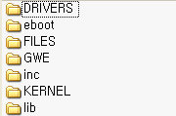
WINCE500/PLATFORM/target/eboot/

[Fig - ] BSP Directory (*WinCE4.2 Basis)

File Name | Contents | Remark
am29lv800.c | AMD nor flash firmware file
blcomm.c | BootloaderMain function file
bootpart.cpp | Boot partition file
cacheflush.c | OEM cache function file
cs8900.c | CS8900 firmware file
debug.c | Serial function file
ether.c | Ethernet function file
flash.c | Nor flash file
fmd.c | Just linked file to drivers/nandflash/fmd/fmd.cpp
format.c | Simple formatted output string file
main.c | Boot loader main c-routine file
nand.c | Nand flash function file
splash.c | LCD display file
arm/ | arm specific assembly directory
cache.s | Cache & TLB operation file
fw.s | Startup function file
mmu.s | Kernelstart function file
nandio.s | Just include drivers/nandflash/fmd/nand.s
util.s | Launch function file
- Don’t need to porting
- Need to porting
- If needs, porting
[Table - ] Boot Loader Porting Files

Kernel Porting List

WINCE500/PLATFORM/target/kernel/

[Fig - ] BSP Directory (*WinCE4.2 Basis)

File Name | Contents | Remark
buildexe/
kitlstub.c | Kitl support file (???)
cachemode.s | OEM cache mode setting file
hal/ | Hardware Adaptation Layer directory
cacheflush.c | Same as eboot/cacheflush.c
cfw.c | C-routine file
debug.c | OEM Serial routine
halether.c | OEM ether routine
iic.c | I2C routine Omni vision
key1024.c | Certification routine
mdppfs.c | Parallel port using file system
oemioctl.c | OEM IOctl routine file
pcmcia.c | PCMCIA relevant file
power.c | Power management routine file
hal/arm/
armint.c | OEM interrupt routine file
cache.s | Same as eboot/arm/cache.s
dabort.s | Data abort processing assembly file
fw.s | Same as eboot/arm/fw.s
mmu920t.s | Co-processor access macro for ARM920T
mmu_h.s | MMU/MPU H/W specific macro definition file
mmumacro.s | Generic aliases for co-processor access macro
odoregs.h | Don’t use
mmu_h.h | Don’t use
oemabort.s | Header file for the data abort
serial.c | Serial read/write function file
timer.c | Timer relevant file
profiler/arm
mdprof.c | Platform specific profiler supporting file
- Don’t need to porting
- Need to porting
- If needs, porting
[Table - ] Kernel Porting Files

Configuration File

File Name | Contents | Remark
eboot/
boot.bib | Four part : MEMORY/CONFIG/MODULES/FILES
sources | Specifies included source
makefile | Include makefile.def (public/common/oak/misc/)
makefile.inc | Real makefile
b.bat | DOS batch file
kernel/
dirs | Indicate used sub-directory
b.bat | DOS batch file
kernel/buildexe/kern/
makefile | Just include makefile.def
sources | Specifies included source
kernel/buildexe/kern/
makefile | Just include makefile.def
sources | Specifies included source
kernel/buildexe/kern/
makefile | Just include makefile.def
sources | Specifies included source
kernel/hal
makefile | Just include makefile.def
sources | Specifies included source
kernel/hal/arm/
map.a | Specifies the memory map
memcfg.a | Memory bank configuration file (for ADS)
regtarget.a | Target core register list
kernel/profiler/
makefile | Just incude makefile.def
sources | Specifies included source
- Don’t need to porting
- Need to porting
- If needs, porting
[Table - ] Configure Files

Debugging and Testing

The following table describes the debugging and testing tools available through Windows Mobile 5.0.
Debugging and testing tool | Description
System Debugging | The kernel debugger is a full-featured debugging system that controls the behavior of an operating system (OS) image. It stops all hardware interrupts, halts the entire OS, and provides full-featured debugging support.
Target Control Window | The Target Control dialog box provides useful command-line debugging options. (Can execute shell.exe commands.)
CeLog Event Tracking | The CeLog event tracking subsystem provides powerful and highly customizable event tracking. (CeLogFlush.exe creates a file named Celog.clg)
Hardware-assisted Debugging | Hardware-assisted debugging allows you to debug even when the target does not yet have a working bootloader or operating system.
Emulator | The Emulator simulates the behavior of a Windows CE-based target device on your development workstation.
Remote Tools | Remote Tools allow you to use a development workstation to remotely perform a variety of programming tasks on a Microsoft® Windows® CE–based target device.
Core Connectivity | The Core Connectivity infrastructure manages the communications between a desktop computer and a Windows CE-based target device. Core Connectivity allows you to download an application or run-time image to a target device, and to connect to that device for development and debugging.  (For download image and transport service)
Windows CE Test Kit | The Windows CE Test Kit (CETK) is a tool that you can use to test device drivers that you develop for the Windows Mobile operating system (OS).
[Table - ] Debugging Resource Overview

1) System Debugging and Target Control Window
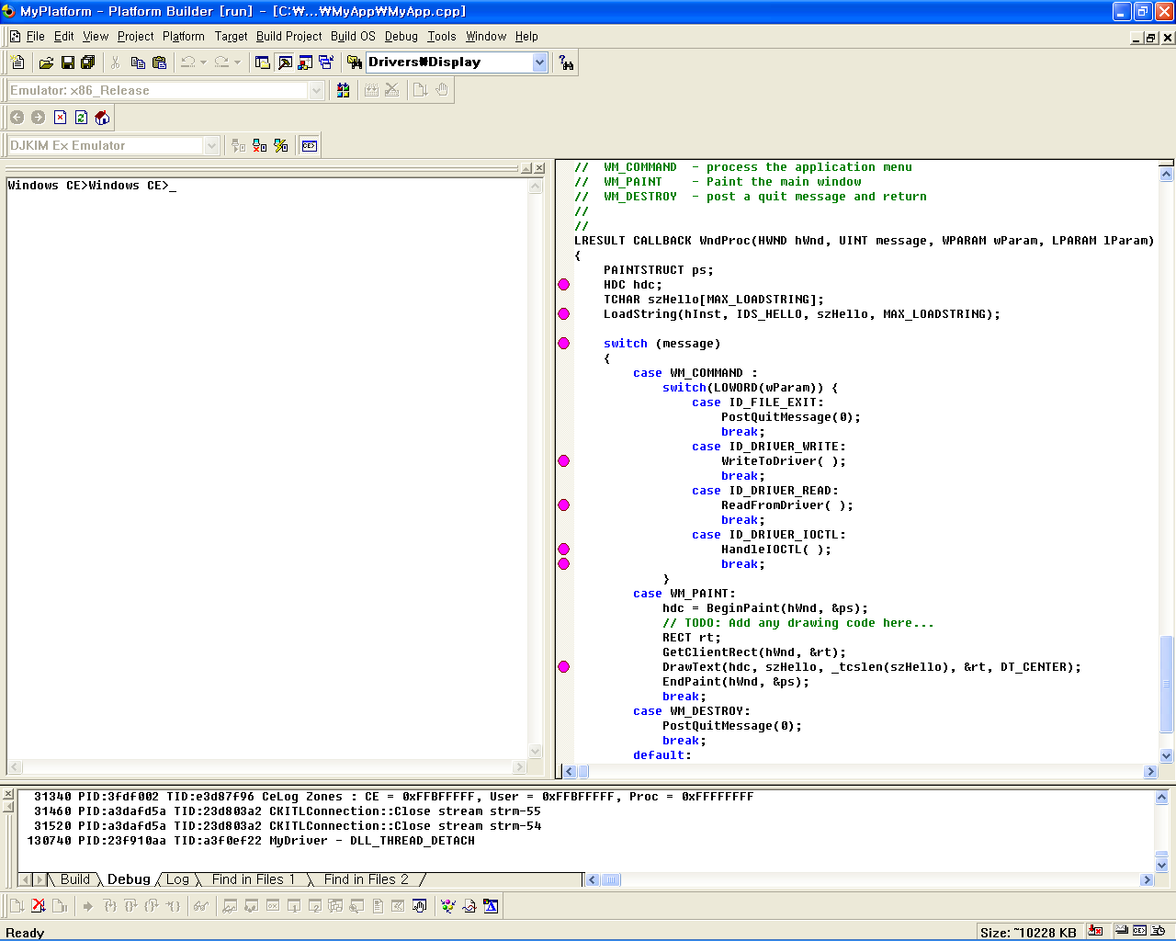
System Debugging

Target Control Window

[Fig - ] Platform Builder Execution Window (Target->Attach Device menu)

2) CeLog Event Tracking and Remote Tools
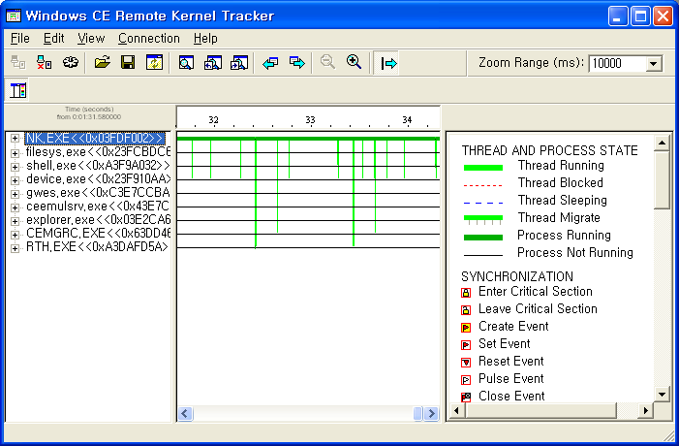
Remote Tools
– Kernel Tracker
[Fig - ] Remote Kernel Tracker Window(Tools->Remote Kernel Tracker menu)

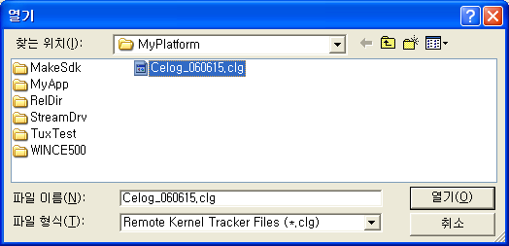
(When .cls file is loading in the Remote Kernel Tracker)
[Fig - ] CeLog file Load Figure

Boot Loader

1) Test boot loader communications. (Serial or Ethernet connection etc.)
2) Verify that the boot loader can use Platform Builder to download a .bin file
Refer to Verifying .bin File Download
3) To verify the RAM or flash memory used by the run-time image before the run-time image is downloaded completely, add support for memory verification.
Refer to Adding Support for Memory Verification

Kernel

The Hardware-assisted Debugging method is debugging method from kernel development process. Others are the method when kernel operation is normal.

1) Hardware-assisted Debugging
Third-party vendors provide the required hardware and software, which includes, at a minimum, a probe driver, and a probe. ex) Trace32, Jtag-Z, etc
2) System Debugging
can use the kernel debugger in the IDE to debug a run-time image on a target device.
3) Remote Tools
Ethernet or serial connection is valid.
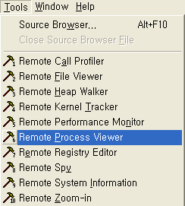
[Fig - ] Remote Tools in the Platform Builder

Remote tool | Description
Remote Call Profiler | Provides profiling and analysis tools within a graphical user interface (GUI) that enable you to identify algorithmic bottlenecks in your applications.
Remote File Viewer | Displays a hierarchical view of the file system on a target device.
Remote Heap Walker | Displays information about heap identifiers and flags for processes that are running on a target device.
Remote Kernel Tracker | Provides a visual representation of OS and application events occurring on a target device.
Remote Performance Monitor | Measures the performance of a target device.
Remote Process Viewer | Displays a list of processes and threads running on a target device.
Remote Registry Editor | Displays the registry for a target device and enables you to manage the registry.
Remote Spy | Displays a list of windows opened on a target device and messages generated by those windows.
Remote System Information | Displays system settings and properties for a target device.
Remote Zoom-in | Displays an image from the screen of a target device.
[Table - ] Remote Tools in the Platform Builder

4) Emulator

APPENDIX

A. Reference (MSDN Site)

1) WinCE5.0 BSP, Boot Loader, and Kernel Starup Sequence
2) How to Develop a Boot Loader
3) How to Develop an OAL(OEM Adaptation Layer)
4) Debugging and Testing

B. Important Functions and Files
1) Boot Loader

2) Kernel

